Security Group | Inbound Rules | Outbound Rules
Bastion Host SG | - SSH (22) from your trusted IP | - Allow SSH (22) to FE Server SG & BE Server SG
FE ALB SG (Public) | - HTTP (80) from 0.0.0.0/0 | - Allow HTTP (80) to FE Server SG
FE Server SG (Reverse Proxy, Private Subnet) | - HTTP (80) from FE ALB SG  – SSH (22) from Bastion Host SG | - Allow HTTP (5000) to BE ALB SG
BE ALB SG (Internal) | - HTTP (5000) from FE Server SG | - Allow HTTP (5000) to BE Server SG
BE Server SG (Private Subnet) | - HTTP (5000) from BE ALB SG - SSH (22) from Bastion Host SG | - Allow DB traffic (e.g., MySQL 3306 / PostgreSQL 5432) to DB SG
DB SG (Private Subnet) | - DB port (3306/5432) from BE Server SG | - Outbound as required (e.g., monitoring/backup services)

- Flow Recap
- Internet → FE ALB (80) → FE Server (reverse proxy, 80)
- FE Server → BE ALB (5000) → BE Server (5000)
- BE Server → DB (3306/5432)
- Bastion Host → FE/BE Servers (22) for admin access

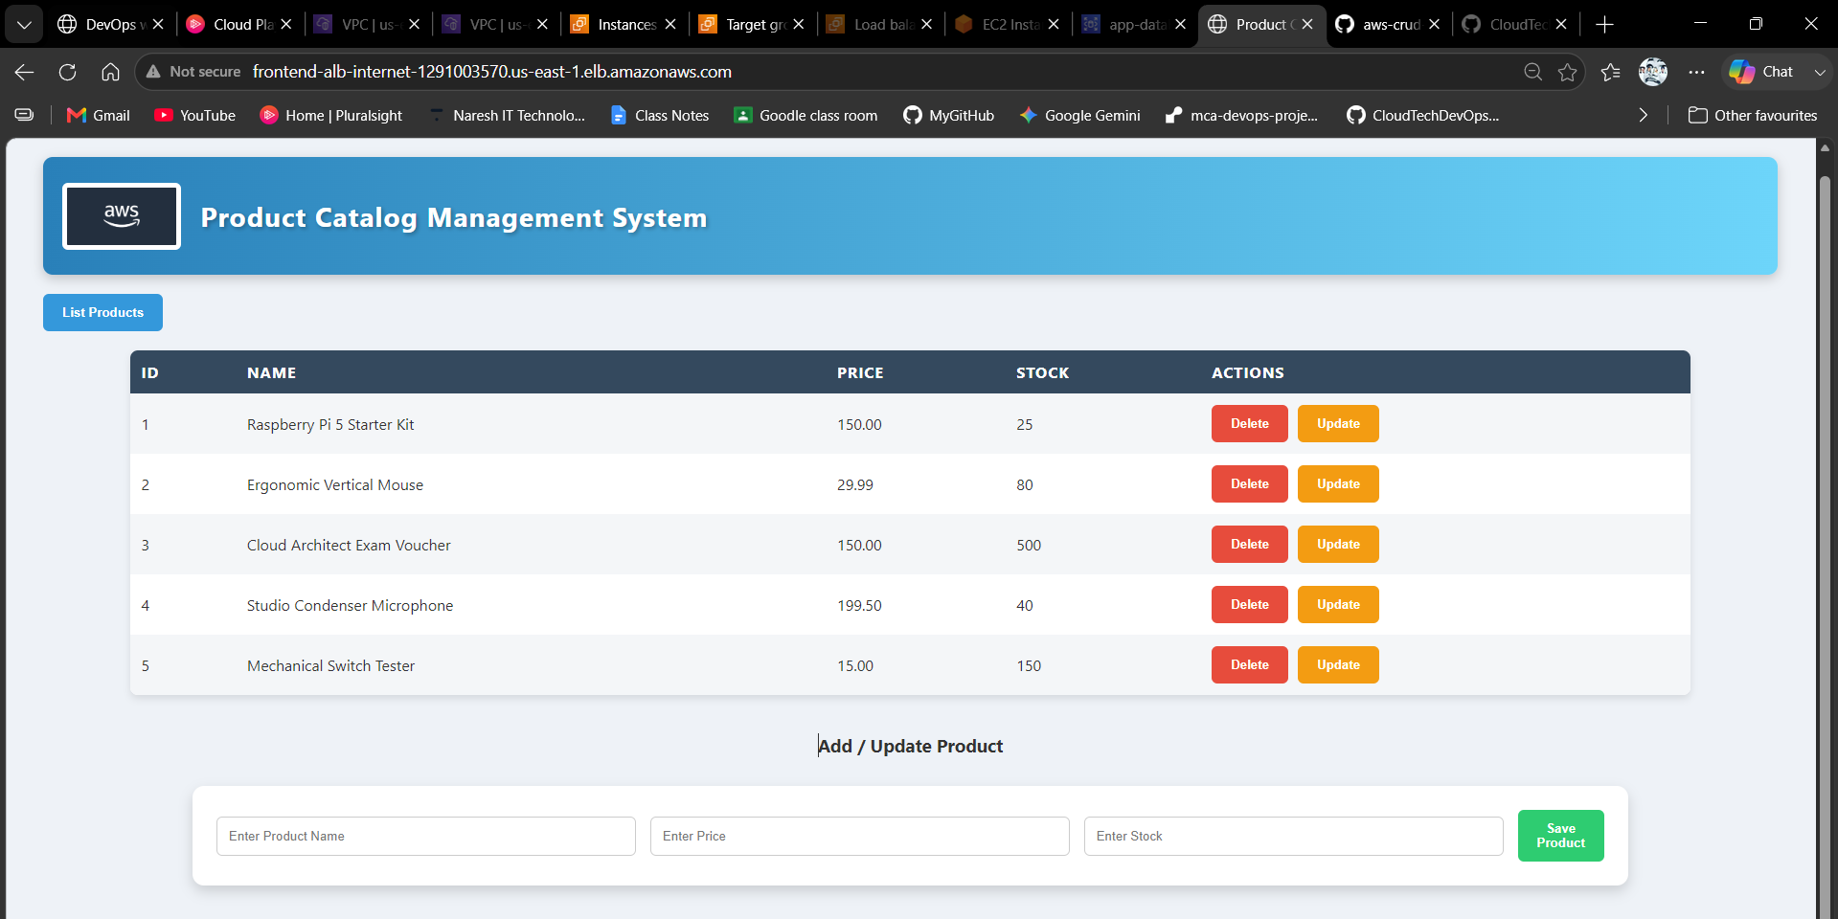
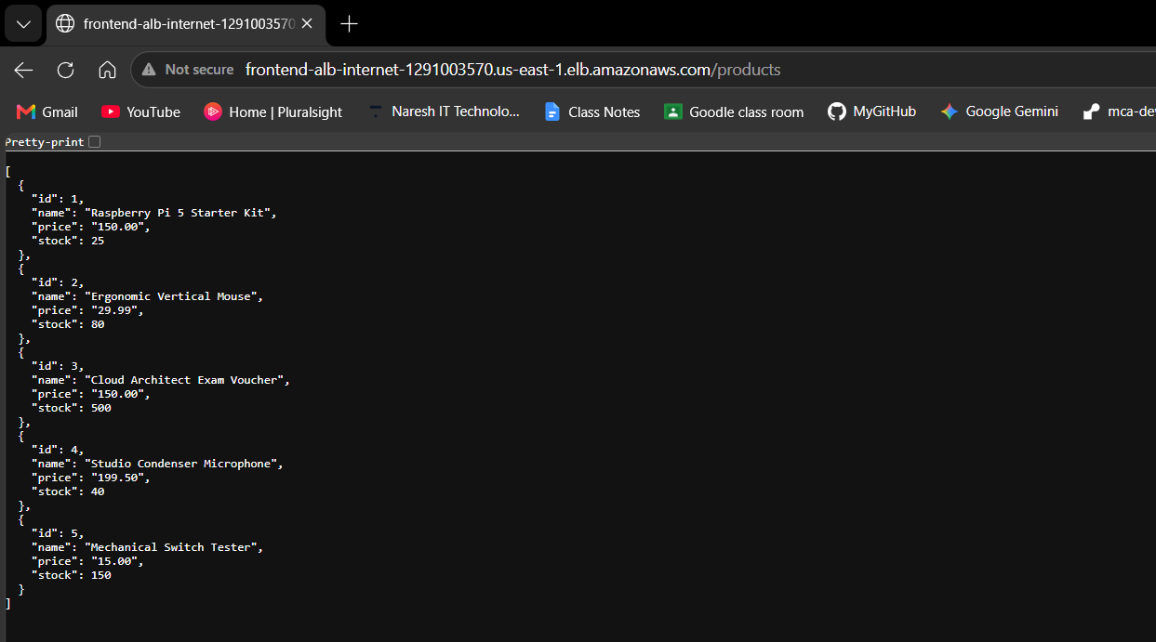

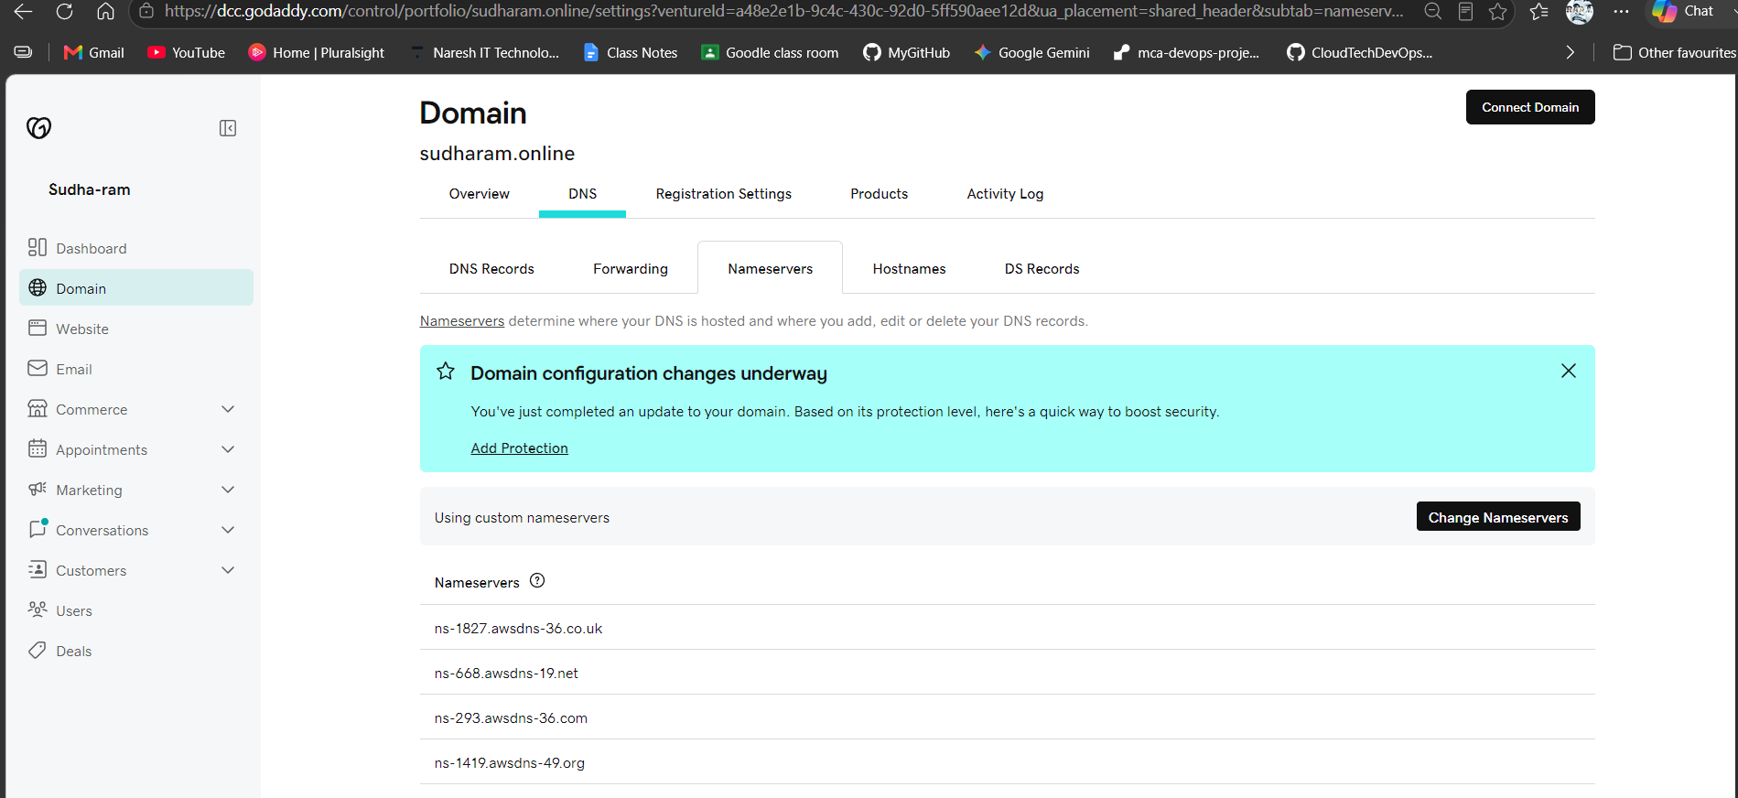

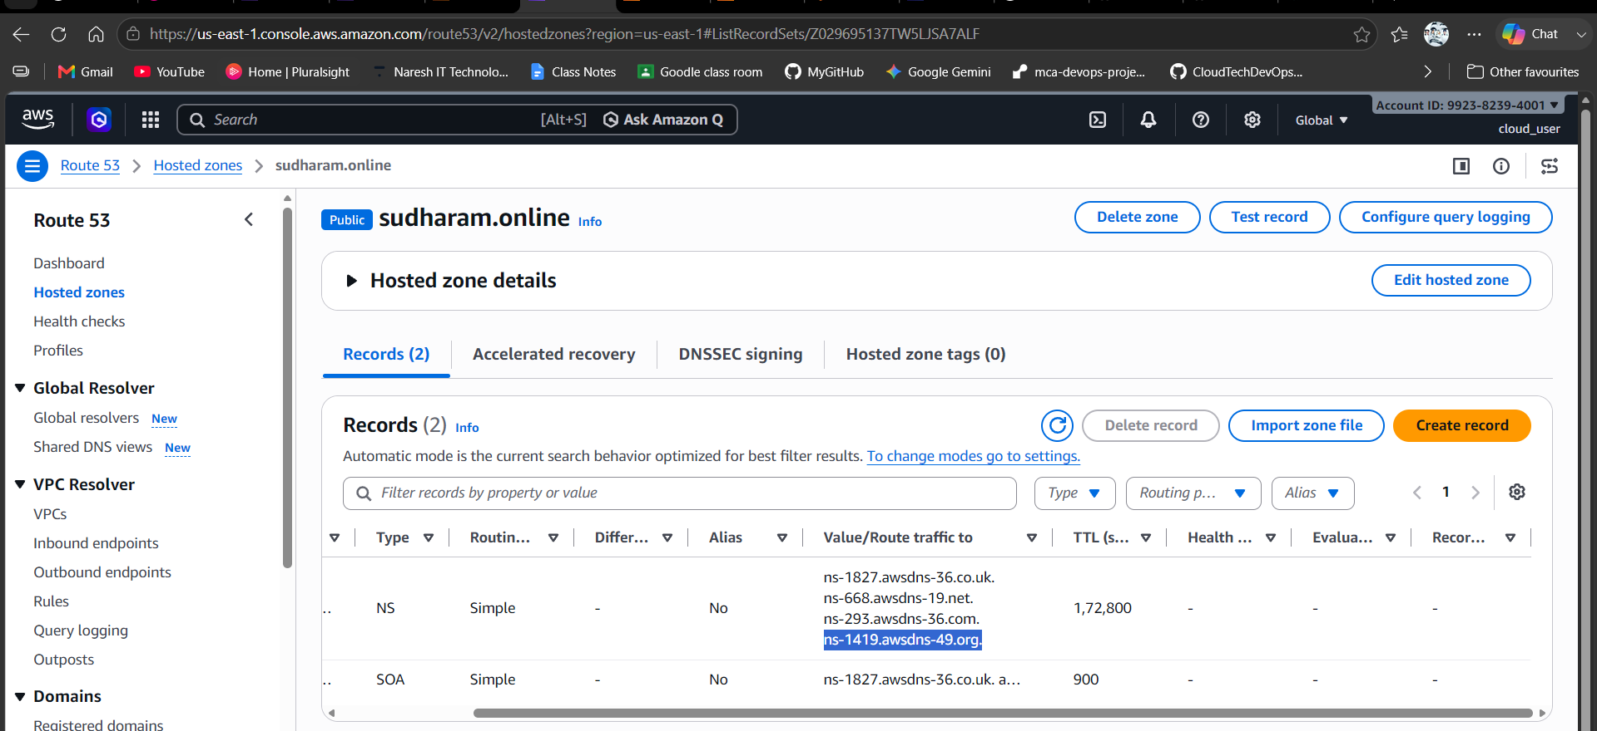

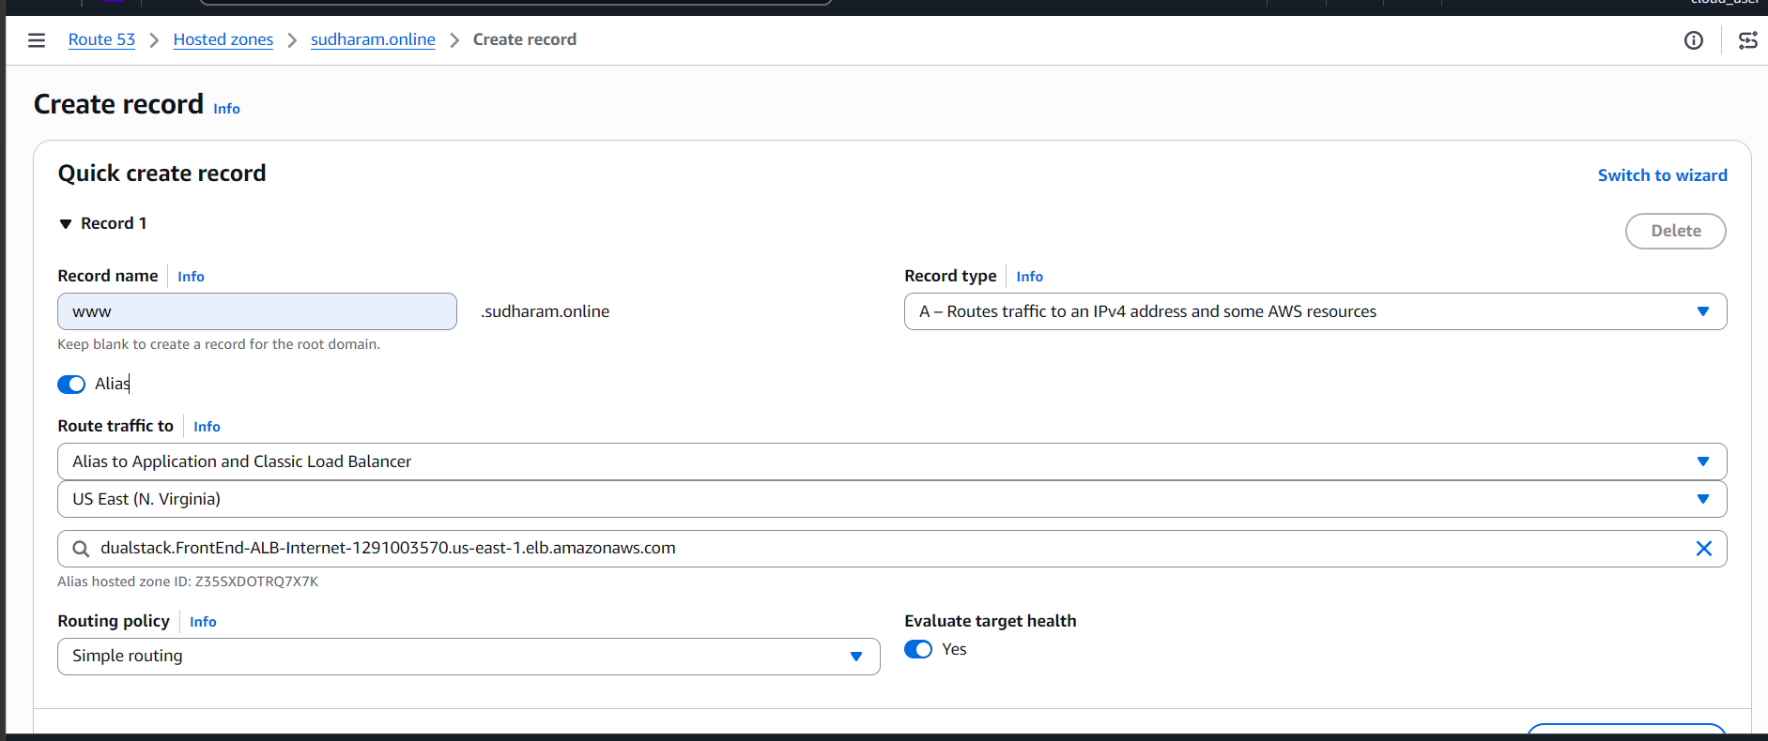
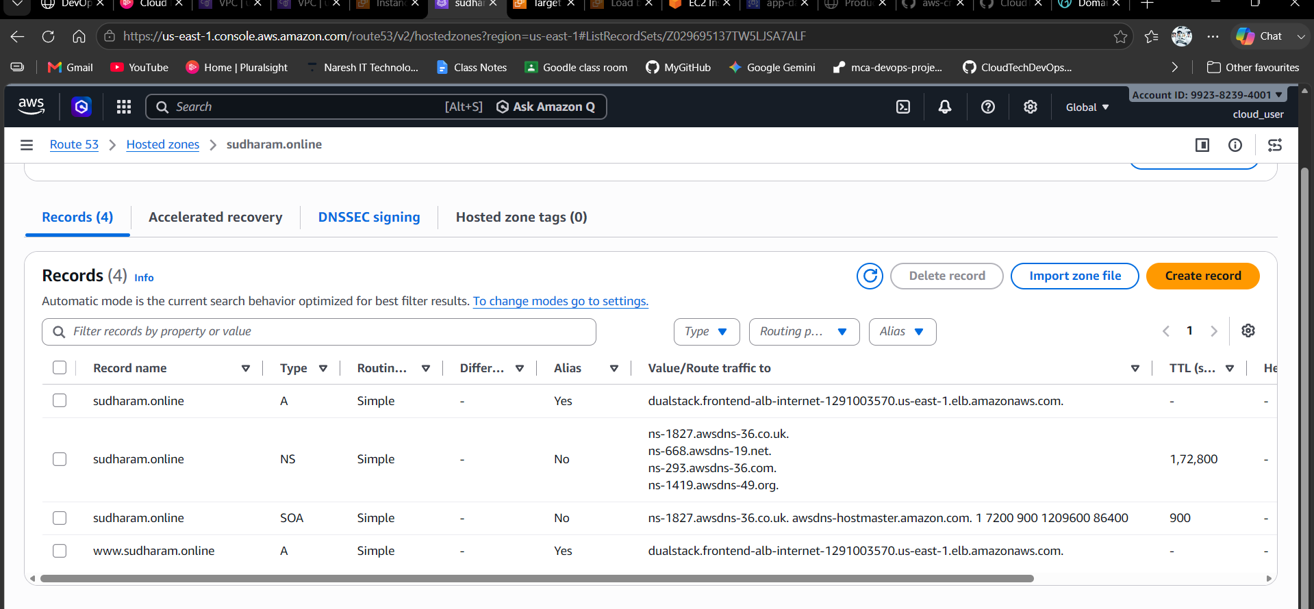
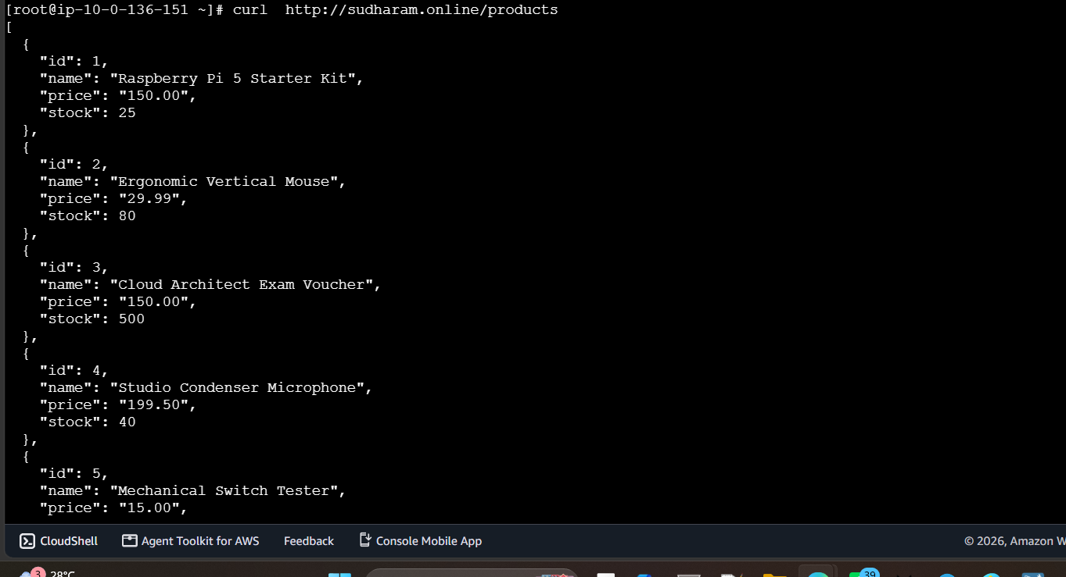

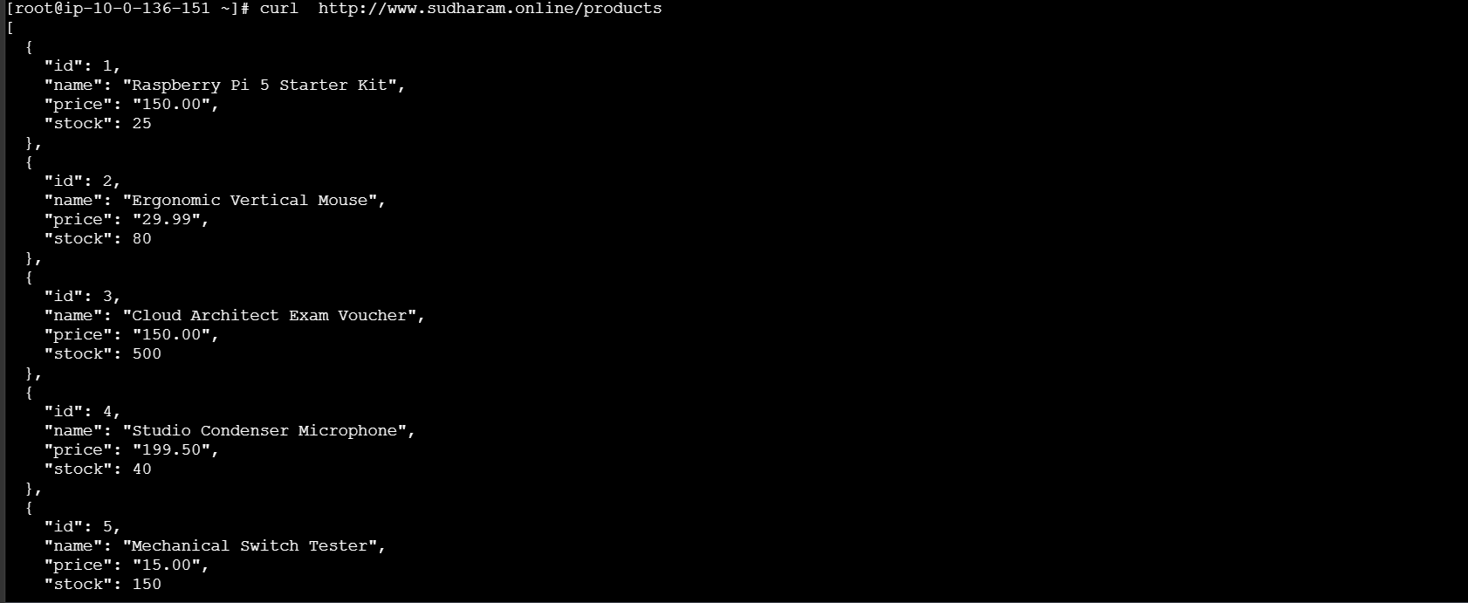

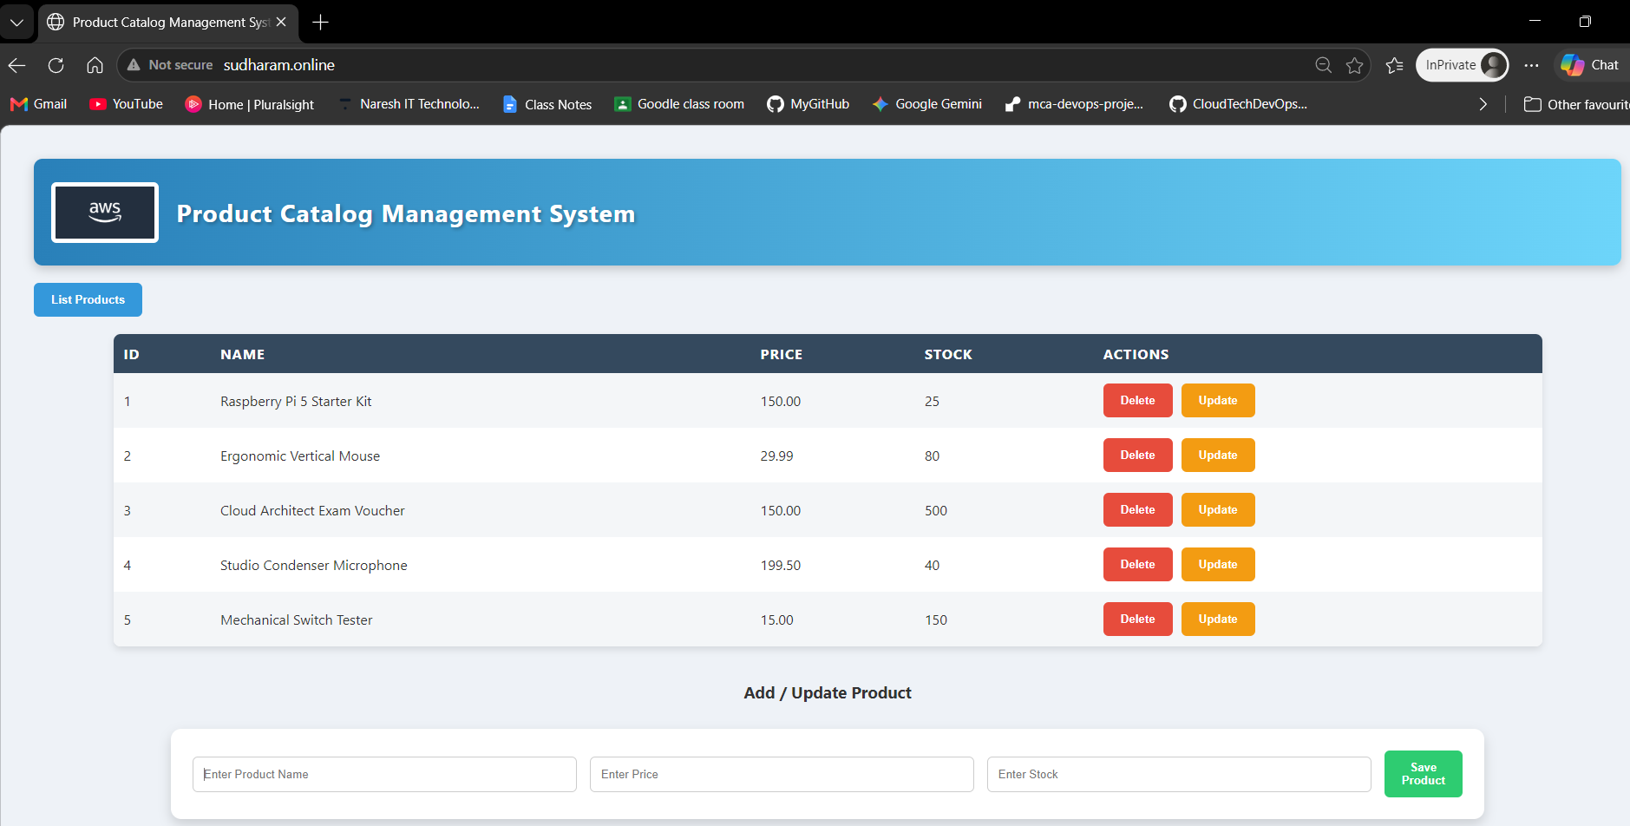
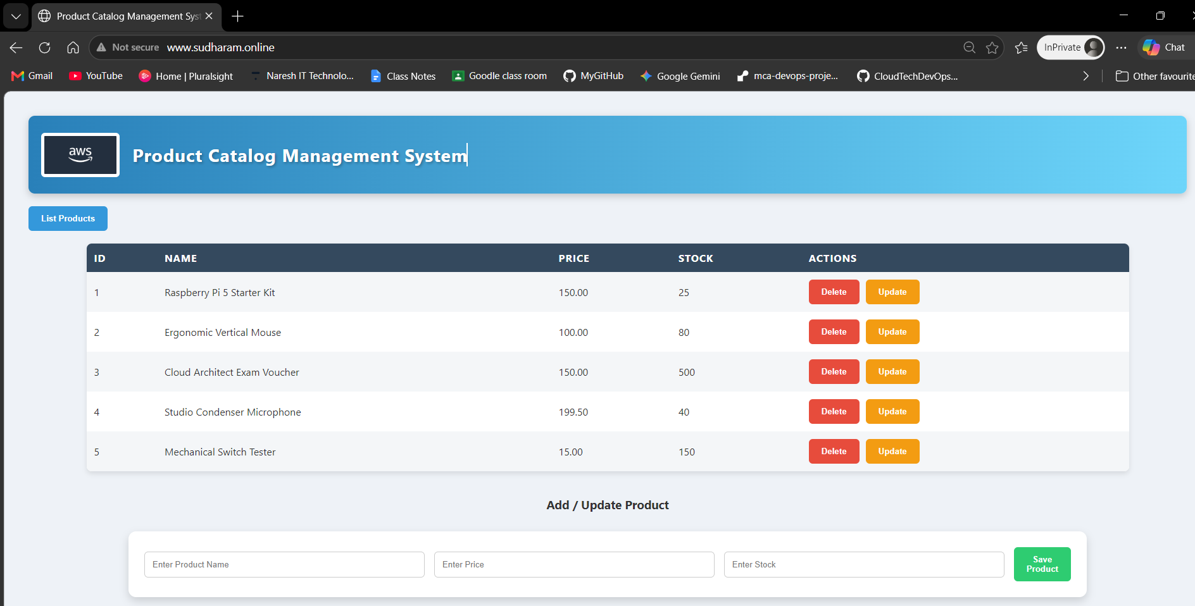

📘 Project Document: sudharam.online Cloud Architecture
1. Introduction
This project demonstrates hosting a 3-tier application on AWS with Route 53, ALB, EC2, RDS, and Auto Scaling. The goal is to provide a scalable, secure, and production-ready deployment.
2. Architecture Overview
- Frontend Layer
  - Nginx EC2 instances behind a public ALB.
  - Serves static UI and proxies API requests.
- Backend Layer
  - Flask EC2 instances behind a private ALB.
  - Handles business logic and connects to RDS.
- Database Layer
  - Amazon RDS (MySQL/Postgres).
  - Private subnet, accessible only from backend EC2s.
- DNS Layer
  - Route 53 hosted zone for sudharam.online.
  - A records for root and www pointing to frontend ALB.
- Scaling & Resilience
  - Auto Scaling Group for backend EC2s.
  - Health checks via ALB.
  - Security Groups layered for frontend, backend, and DB.

3. Step-by-Step Implementation
- Domain Setup
  - Registered domain at GoDaddy.
  - Updated nameservers to Route 53.
  - Created hosted zone in Route 53.
- DNS Records
  - A record (Alias) for sudharam.online → Frontend ALB.
  - A record (Alias) for www.sudharam.online → Frontend ALB.
- Frontend ALB
  - Listener on port 80 (HTTP).
  - Target group → Nginx EC2s.
  - ACM certificate attached for HTTPS (443).
- Backend ALB
  - Internal ALB in private subnets.
  - Target group → Flask EC2s.
  - Nginx proxies /products → backend ALB.
- Database
  - RDS in private subnet.
  - Security Group allows 3306 only from backend SG.
- Auto Scaling Group
  - Launch Template with Flask EC2 AMI + user data.
  - ASG min=1, desired=2, max=4.
  - Scaling policy: CPU >70% → scale out, <30% → scale in.
  - Health check type: ELB.

4. Security Groups
- Frontend SG: Allow 80/443 from 0.0.0.0/0.
- Backend SG: Allow 5000 from Frontend SG.
- DB SG: Allow 3306 from Backend SG.

5. Monitoring & Logging
- CloudWatch alarms for CPU/memory.
- ALB access logs enabled.
- RDS enhanced monitoring.

6. Architecture Diagram
Code
User → Route53 → Frontend ALB → Nginx EC2s
↓
Backend ALB → Flask EC2s (ASG)
↓
RDS

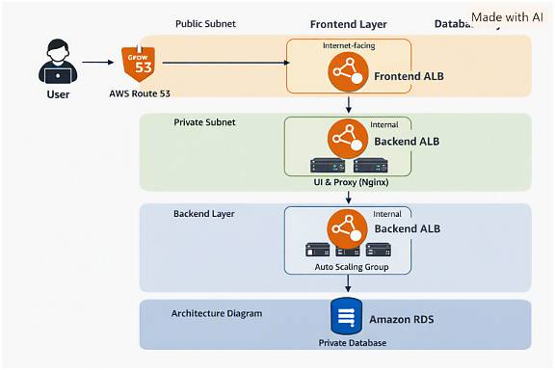
7. Conclusion
This setup ensures:
- High availability (ALB + ASG).
- Scalability (auto scaling backend).
- Security (layered SGs, private DB).
- Branding (custom domain via Route 53).

